**American International University-Bangladesh (AIUB)**

**Faculty of Engineering**

|  |  |  |  |
| --- | --- | --- | --- |
| **Course Name:** | COMPUTER AIDED DESIGN AND DRAFTING | **Course Code:** | BAE 2101 |
| **Semester:** | Fall 2020-2021 | **Section:** |  |
| **Faculty:** | Rethwan Faiz | **Assignment No:** | 2 |
| **Assignment Name:** | **OBE Assignment (CO2 & CO4)** | | |
| **Submission Date:** |  | | |

|  |  |  |  |  |
| --- | --- | --- | --- | --- |
| **Category** | **Excellent** | **Good** | **Acceptable** | **Secured Marks** |
| Civil Plan | The civil plan is unique and drawn as per requirements with proper dimensions  [7-10] | The civil plan is drawn partially as per requirement with minor errors  [4-6] | The civil is either copied or very poor with major errors.  [1-3] |  |
| Electric Fittings | The fittings are placed rationally and maintaining BNBC  [4-5] | The fittings are placed rationally but not maintaining BNBC  [2-3] | The fittings are placed randomly and not maintaining BNBC  [1] |  |
| Conduit Layout | The conduit layout is done properly maintaining color code and standard connection practices.  [4-5] | The conduit layout is done maintaining color code but not maintaining standard connection practices  [2-3] | The conduit layout is not done maintaining color code and standard connection practices.  [1] |  |
| Load Calculation | The load calculation is done correctly according to BNBC.  [4-5] | The load calculation is done according to BNBC but with minor errors  [2-3] | The load calculation is done not according to BNBC with major errors  [1] |  |
| Generator Capacity and Generator Room | The generator is chosen properly, and the generator room is designed according to BNBC  [4-5] | The generator is chosen properly but the generator room is not designed according to BNBC  [2-3] | The capacity of the generator chosen is wrong and also the generator room is not designed according to BNBC  [1] |  |
| Comments |  | | Total Marks:  (Out of 30 Marks) |  |

|  |  |  |  |  |
| --- | --- | --- | --- | --- |
| **SL #** | **ID** | **Student Name** | **Department** | **Marks** |
| **1.** | 20-42213-1 | Ahnaf Faiaz | Cse |  |
| **2.** | 20-42217-1 | Muhaiminul Ashrafee | Cse |  |
| **3.** | 20-42996-1 | Asif Hossein Neloy | Cse |  |
| **4.** |  |  |  |  |
| **5.** |  |  |  |  |

**Question #** Mr. X & Mrs. Y have purchased a land of 5 Kathas from **ABC Housing Ltd.** which is located at Bashundhara R/A, Dhaka. Now they want to construct a 5 Storied building (**Ground + 0 Floors**) of having 3/4 units – A, B & C/D in each floor. You are asked to design for only B unit flat of having **1000 sq-ft** (approx.) based on the following specifications:

* *2 Bed Room (size: Bed-1 (master Bed) is 00' x 00'0”, Bed-2 is 00' x 00', Bed-3 is 00' x 0'0”)*
* *2 bath (Size: Attached bath of Bed-2 is 0'0'' x 0', bath of Bed-1 is 0'0'' x 0', Common Bath is 0' x 0')*
* *Living/Drawing (Size: 00' x 00')*
* *Dining*
* *Kitchen (Size: 0' x 0')*
* *2 Veranda (Size: Ver_Bed-1 is 0'0'' x 0', Ver_Bed-2 is 0'0'' x 0', Bed-3 is 0' x 0')*
* *Door for kitchen / bathroom / veranda - 2'6'', Door for Bed Room - 3' and Main Door 4' (interior to interior)*

**Considering the abovementioned specifications do the following using AutoCAD 2007 Software:**

1. **Draw the** **Civil Plan** of the flatalong with **stair, lift** and **lobby (Space: 00*' x 00'****, which is excluded from the flat size***)**. [*Hints: Brick to interior/exterior Offset distance = 0*'',* Stair Offset distance = 0*''*]. **10 points**
2. **Draw** the **proper Electric Fittings (applying BNBC) 5 points**
3. **Draw** the **electric conduit layout (Wiring – applying BNBC)** where **Red, Blue & Yellow color** represents **light load, medium load & heavy load** respectively. **5 points**
4. **Calculate** the **load** for **Unit A/B/C** only. Also **Calculate** the **load** for each **floor** and **load for the building** considering all the flat types are same and same types of load. **5 points**
5. **Calculate** the **capacity** of the **Generator** based on the load calculation. **Draw** a separate **Generator room** and **show** the connection with distribution board. **5 points**

**Drawing**

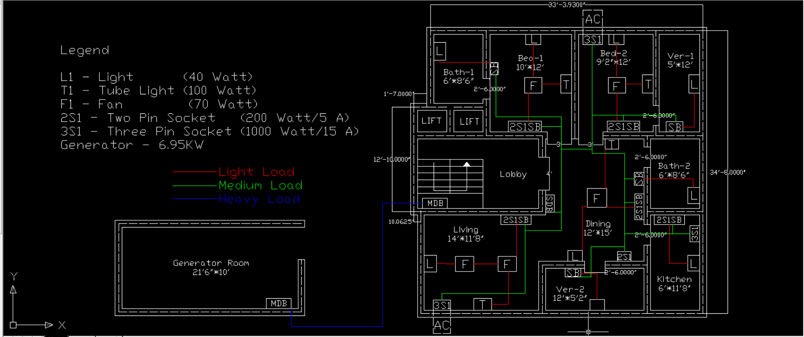

**Load Calculation:**

The load calculations of the above discussed drawing is given below:

So in the Bed room there are total 2 lights, 2 tube lights,2 celling fans, 2 5A sockets and 2 15A sockets.

Lights 🡪 2*100 == 200 watts

Tubelights 🡪 2*40 == 80 watts

Fans 🡪 2*70 == 140 watts

5A sockets 🡪 2*200 == 400 watts

15A sockets 🡪 1000 == 1000 watts

Total == 1820 watts

Again, in the drawing there are two bathroom which have 1 light per bathroom

Bathroom:

Lights 🡪 2*100 == 200 watts

Veranda:

Lights 🡪2*100 == 200 watts

Again, Kitchen has 1 light, 5A socket and 15A socket.

Kitchen:

5A socket 🡪 200 == 200 watts

15A socket 🡪 1000 == 1000 watts

Lights 🡪 100 == 100 watts

Total == 1300 watts

Dinning Room:

Tublight 🡪 40 == 40 watts

Light 🡪 100 == 100 watts

Fan 🡪 70 == 70 watts

5A sockets 🡪 200 == 200 watts

Total == 410 watts

Drawing Room:

Tublight 🡪 40 == 40 watts

Lights 🡪 100 == 100 watts

Fan 🡪 2*70 == 140 watts

5A socket 🡪 2*200 == 400 watts

15A socket 🡪 1000 == 1000watt

Total == 1680 watts

Load Calculation of the unit : (1820+200+1300+200+410+1680+200) = 5810 watts or 5.81 kW

Assuming every unit has same unit load

Total Load of the floor is: (5.81*3) or 17.43 kW

Total Load of the Building is (17.43* 4 ) or 69.72 kW

Generator:

For each unit we assume we have connections for 2 light and 2 fans. Generator also supplies power for lift, floor lights and common room light and a common room fan.

Light 🡪 200*3*4 == 2400watts

Fans 🡪 140 *3*4 == 1680watts

Lift 🡪 2000 watts == 2000watts

Floor Lights 🡪 700 watts == 700 watts

Common room🡪 170 watts == 170 watts

Total 🡪 6950 watts or 6.95kW

By BNBC codes we need at least a 20 square meter room for the generator as our total loads gets to 6.95kW.

*Total Load of the unit:* 5.81 kW

*Total Load of the floor is:* 17.43 kW

*Total Load of the Building is:* 69.72 kW

Contributions:

Civil Plan - Asif Hossain Neloy

Electric Fittings - Ahnaf Faiaz & Asif Hossain Neloy

Electric Conduit Layout - Ahnaf Faiaz & Muhaiminul Ashrafee

Calculation - Muhaiminul Ashrafee